**South Africa country profile**

Published

13 May 2019

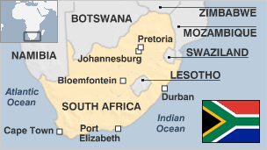

**South Africa has one of the continent's biggest and most developed economies.**

Up until 1994 it was ruled by a white minority government, which enforced a separation of races with its policy called apartheid.

The apartheid government eventually negotiated itself out of power after decades of international isolation, armed opposition and mass protests.

The democratically-elected leadership encouraged reconciliation and set about redressing social imbalances, but the economy has struggled.

* Read profiles by [BBC Monitoring](http://bbc.co.uk/monitoring)

**President: Cyril Ramaphosa**

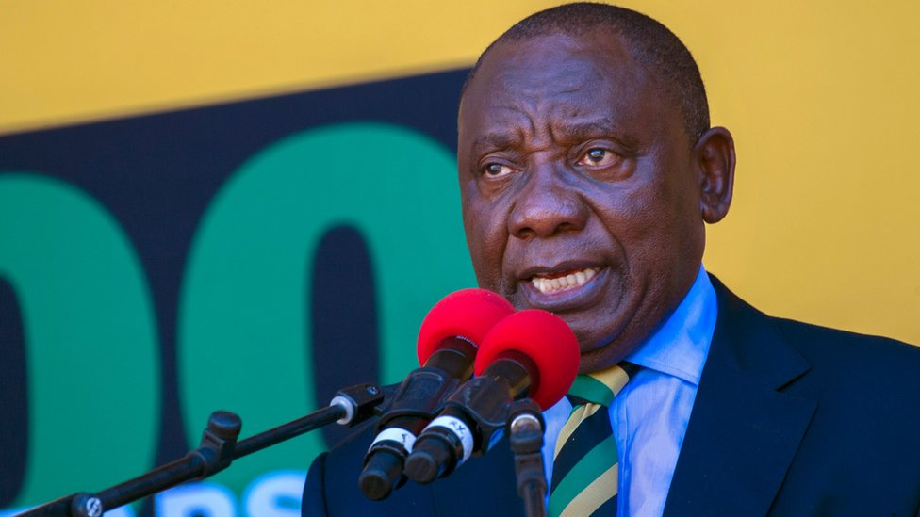image copyrightGetty Images

Cyril Ramaphosa was elected president by parliament in February 2018 after his predecessor, Jacob Zuma, resigned over corruption allegations.

A successful but sometimes controversial businessman, Mr Ramaphosa was picked as leader of the governing African National Congress (ANC) a few months earlier.

He inherited a struggling economy, a divided party, and the problem of entrenched corruption.

Unlike many senior party figures of his generation, Mr Ramaphosa was not driven into exile for opposing apartheid.

He fought the injustices of white minority rule from within South Africa, most prominently by defending the rights of black miners as leader of the National Union of Mineworkers (NUM).

He was heavily involved in the talks to end apartheid, and played an important role in the drafting of South Africa's post-apartheid constitution.

After missing out on becoming then President Nelson Mandela's deputy, Mr Ramaphosa withdrew from active political life, switching focus to business.

He returned as deputy president in 2014, before finally taking the top job from the scandal-plagued Mr Zuma. He passed his first test when the ANC won the May 2019 parliamentary elections, although its 58% share of the vote was its lowest margin of victory since the end of apartheid.

[Read full profile](http://www.bbc.co.uk/news/world-africa-17450447)

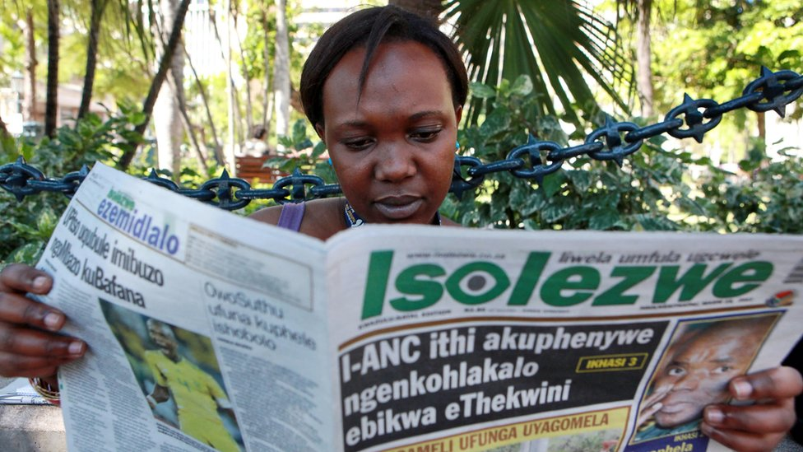image copyrightGetty Images

South Africa is the continent's major media player, and its broadcasters and press reflect the diversity of its people.

Established state-run and commercial TV broadcast nationally, and hundreds of thousands of viewers subscribe to satellite and cable. South Africa-based MultiChoice markets satellite pay-TV in dozens of African countries.

**South Africa profile - Timeline**

Published

4 April 2018

**A chronology of key events:**

**4th century** - Migrants from the north settle, joining the indigenous San and Khoikhoi people.

**1480s** - Portuguese navigator Bartholomeu Dias is the first European to travel round the southern tip of Africa.

**1497** - Portuguese explorer Vasco da Gama lands on Natal coast.

**1652** - Jan van Riebeeck, representing the Dutch East India Company, founds the Cape Colony at Table Bay.

**1795** - British forces seize Cape Colony from the Netherlands. Territory is returned to the Dutch in 1803; ceded to the British in 1806.

**1816-1826** - Shaka Zulu founds and expands the Zulu empire, creates a formidable fighting force.

**1835-1840** - Boers leave Cape Colony in the 'Great Trek' and found the Orange Free State and the Transvaal.

**1852** - British grant limited self-government to the Transvaal.

**1856** - Natal separates from the Cape Colony.

**Late 1850s** - Boers proclaim the Transvaal a republic.

**1860-1911** - Arrival of thousands of labourers and traders from India, forebears of the majority of South Africa's current Indian population.

**1867** - Diamonds discovered at Kimberley.

**1877** - Britain annexes the Transvaal.

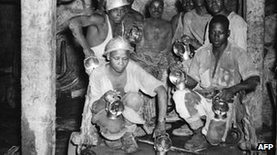image copyrightAFP

image captionMining has been the driving force behind South Africa's economic development

**1879** - British defeat the Zulus in Natal.

**1880-81** - Boers rebel against the British, sparking the first Anglo-Boer War. Conflict ends with a negotiated peace. Transvaal is restored as a republic.

**Mid 1880s** - Gold is discovered in the Transvaal, triggering the gold rush.

**1899** - British troops gather on the Transvaal border and ignore an ultimatum to disperse. The second Anglo-Boer War begins.

**1902** - Treaty of Vereeniging ends the second Anglo-Boer War. The Transvaal and Orange Free State are made self-governing colonies of the British Empire.

**1910** - Formation of Union of South Africa by former British colonies of the Cape and Natal, and the Boer republics of Transvaal, and Orange Free State.

**1912** - Native National Congress founded, later renamed the African National Congress (ANC).

**1913** - Land Act introduced to prevent blacks, except those living in Cape Province, from buying land outside reserves.

**1914** - National Party founded.

**1918** - Secret Broederbond (brotherhood) established to advance the Afrikaner cause.

**1919** - South West Africa (Namibia) comes under South African administration.

**1934** - The Union of South Africa parliament enacts the Status of the Union Act, which declares the country to be "a sovereign independent state". The move followed on from Britain's passing of the Statute of Westminster in 1931, which removed the last vestiges of British legal authority over South Africa.

**Apartheid set in law**

**1948** - Policy of apartheid (separateness) adopted when National Party (NP) takes power.

**1950** - Population classified by race. Group Areas Act passed to segregate blacks and whites. Communist Party banned. ANC responds with campaign of civil disobedience, led by Nelson Mandela.

**1960** - Seventy black demonstrators killed at Sharpeville. ANC banned.

**1961** - South Africa declared a republic, leaves the Commonwealth. Mandela heads ANC's new military wing, which launches sabotage campaign.

**1960s** - International pressure against government begins, South Africa excluded from Olympic Games.

**1964** - ANC leader Nelson Mandela sentenced to life imprisonment.

**1966** September - Prime Minister Hendrik Verwoerd assassinated.

**1970s** - More than 3 million people forcibly resettled in black 'homelands'.

**1976** - More than 600 killed in clashes between black protesters and security forces during uprising which starts in Soweto.

**1984-89** - Township revolt, state of emergency.

**1989** - FW de Klerk replaces PW Botha as president, meets Mandela. Public facilities desegregated. Many ANC activists freed.

**1990** - ANC unbanned, Mandela released after 27 years in prison. Namibia becomes independent.

**1991** - Start of multi-party talks. De Klerk repeals remaining apartheid laws, international sanctions lifted. Major fighting between ANC and Zulu Inkatha movement.

**1993** - Agreement on interim constitution.

**1994** April - ANC wins first non-racial elections. Mandela becomes president, Government of National Unity formed, Commonwealth membership restored, remaining sanctions lifted. South Africa takes seat in UN General Assembly after 20-year absence.

**Seeking truth**

**1996** - Truth and Reconciliation Commission chaired by Archbishop Desmond Tutu begins hearings on human rights crimes committed by former government and liberation movements during apartheid era.

**1996** - Parliament adopts new constitution. National Party withdraws from coalition, saying it is being ignored.

**1998** - Truth and Reconciliation Commission report brands apartheid a crime against humanity and finds the ANC accountable for human rights abuses.

**1999** - ANC wins general elections, Thabo Mbeki takes over as president.

**2000** December - ANC prevails in local elections. Recently-formed Democratic Alliance captures nearly a quarter of the votes. The Inkatha Freedom Party wins 9%.

**2001** April - 39 multi-national pharmaceutical companies halt a legal battle to stop South Africa importing generic Aids drugs. The decision is hailed as a victory for the world's poorest countries in their efforts to import cheaper drugs to combat the virus.

**2001** May - An official panel considers allegations of corruption surrounding a 1999 arms deal involving British, French, German, Italian, Swedish and South African firms. In November the panel clears the government of unlawful conduct.

**2001** September - Durban hosts UN race conference.

**2001** December - High Court rules that pregnant women must be given Aids drugs to help prevent transmission of the virus to their babies.

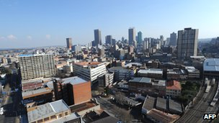image copyrightAFP

image captionJohannsburg - known as Jozi, Jo'burg or eGoli - is South Africa's largest city and economic hub

**2002** April - Court acquits Dr Wouter Basson - dubbed "Dr Death" - who ran apartheid-era germ warfare programme. Basson had faced charges of murder and conspiracy. ANC condemns verdict.

**2002** July - Constitutional court orders government to provide key anti-Aids drug at all public hospitals. Government had argued drug was too costly.

**2002** October - Bomb explosions in Soweto and a blast near Pretoria are thought to be the work of right-wing extremists. Separately, police charge 17 right-wingers with plotting against the state.

**2003** May - Walter Sisulu, a key figure in the anti-apartheid struggle, dies aged 91. Thousands gather to pay their last respects.

**2003** November - Government approves major programme to treat and tackle HIV/Aids. It envisages network of drug-distributon centres and preventative programmes. Cabinet had previously refused to provide anti-Aids medicine via public health system.

**2004** April - Ruling ANC wins landslide election victory, gaining nearly 70% of votes. Thabo Mbeki begins a second term as president. Inkatha Freedom Party leader Mangosuthu Buthelezi is dropped from the cabinet.

**2005** March - Investigators exhume the first bodies in a Truth and Reconciliation Commission investigation into the fates of hundreds of people who disappeared in the apartheid era.

**2005** May - Geographical names committee recommends that the culture minister should approve a name change for the capital from Pretoria to Tshwane.

**Zuma sacked**

**2005** June - President Mbeki sacks his deputy, Jacob Zuma, in the aftermath of a corruption case.

**2005** August - Around 100,000 gold miners strike over pay, bringing the industry to a standstill.

**2006** May - Former deputy president Jacob Zuma is acquitted of rape charges by the High Court in Johannesburg. He is reinstated as deputy leader of the governing African National Congress.

**2006** June - Chinese Premier Wen Jiabao visits and promises to limit clothing exports to help South Africa's ailing textile industry.

**2006** September - Corruption charges against former deputy president Zuma are dismissed, boosting his bid for the presidency.

**2006** December - South Africa becomes the first African country, and the fifth in the world, to allow same-sex unions.

**2007** April - President Mbeki, often accused of turning a blind eye to crime, urges South Africans to join forces to bring rapists, drug dealers and corrupt officials to justice.

**2007** May - Cape Town mayor Helen Zille is elected as new leader of the main opposition Democratic Alliance (DA).

**Mass strike**

**2007** June - Hundreds of thousands of public-sector workers take part in the biggest strike since the end of apartheid. The strike lasts for four weeks and causes widespread disruption to schools, hospitals and public transport.

**2007** December - Zuma is elected chairman of the ANC, placing him in a strong position to become the next president. Prosecutors bring new corruption charges against him.

**2008** May - Wave of violence directed at foreigners hits townships across the country. Dozens of people die and thousands of Zimbabweans, Malawians and Mozambicans return home.

**2008** September - A judge throws out a corruption case against ruling ANC party chief Jacob Zuma, opening the way for him to stand as the country's president in 2009.

President Mbeki resigns over allegations that he interfered in the corruption case against Mr Zuma. ANC deputy leader Kgalema Motlanthe is chosen by parliament as president.

**New party launched**

**2008** December - A new political party is launched in Bloemfontein, in the first real challenge to the governing ANC. The Congress of the People - or Cope - is made up largely of defectors from the ANC and is headed by former defence minister Mosiuoa Lekota.

**2009** January - Appeals court rules that state prosecutors can resurrect their corruption case against ANC leader Jacob Zuma, opening the way for Mr Zuma's trial to be resumed, just months before general election.

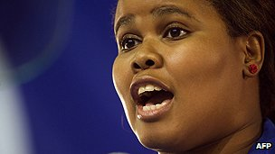image copyrightAFP

image captionLindiwe Mazibuko, the opposition Democratic Alliance's leader in parliament 2011-2014

**2009** April - Public prosecutors drop corruption case against Jacob Zuma.

ANC wins general election.

**2009** May - Parliament elects Jacob Zuma as president.

Economy goes into recession for first time in 17 years.

**2009** July - Township residents complaining about poor living conditions mount violent protests.

**2010** June - South Africa hosts the World Cup football tournament.

**2010** August - Civil servants stage nation-wide strike.

**2011** May - Local elections, with opposition Democratic Alliance nearly doubling its share of the vote since the last poll.

President Zuma mediates in Libyan conflict.

**2011** October - President Zuma sacks two ministers accused of corruption.

Opposition Democratic Alliance picks a black woman - Lindiwe Mazibuko - as its leader in parliament.

**Trouble within ANC**

**2011** November - The ANC suspends its controversial and influential youth leader, Julius Malema, for five years for bringing the party into disrepute.

National Assembly overwhelmingly approves information bill accused by critics of posing a threat to freedom of speech. The ANC says it is needed to safeguard national security.

**2012** July - Member of white extremist group found guilty of plotting to kill Mandela and trying to overthrow government.

**2012** August-October - Police open fire on workers at a platinum mine in Marikana, killing at least 34 people, and leaving at least 78 injured and arresting more than 200 others. Prosecutors drop murder charges in September against 270 miners after a public outcry, and the government sets up a judicial commission of inquiry in October.

**2012** September - Former ANC youth leader Julius Malema is charged with money laundering over a government tender awarded to a company partly owned by his family trust. Mr Malema says the case is a politically motivated attempt to silence his campaign against President Zuma, in particular over the Marikana shootings.

**2012** October - Platinum mine owner Amplats fires 12,000 striking miners as wave of wildcat strikes shows little sign of abating.

**2013** December - Nelson Mandela dies, aged 95. Tributes to "the father of the nation" flood in from throughout the world.

**Fall of Zuma**

**2013** March - The anti-corruption ombudsman heavily criticises President Zuma for a twenty million dollar upgrade to his private home.

**2014** May - Ruling ANC party wins a majority in general elections.

**2014** October - Paralympics athlete Oscar Pistorius - nicknamed the ''Blade Runner'' because of his prosthetic limbs - is sentenced to five years in jail for killing his girlfriend.

**2015** February - President Zuma announces plans to limit farm sizes and ban foreign farmland-ownership in an attempt toredistribute land to black farmers - a longstanding ANC pledge.

Power utility Eskom rations electricity to prevent power cuts, blaming years of poor maintenance.

**2015** March-April - A spate of anti-immigrant attacks leaves several people dead.

**2015** June - Government receives unwelcome international attention over allegations of bribery to disgraced international footballing body Fifa to secure 2010 World Cup, and allowing Sudanese President Omar al-Bashir to visit despite International Criminal Court arrest warrant over genocide and war-crimes charges.

**2016** March - Supreme Court rules President Zuma violated the constitution for not repaying public money used to improve his private residence.

**2017** April - President Zuma dismisses widely-respected Finance Minister Pravin Gordhan, leading to the country's credit rating being cut to junk status.

**2018** February - President Zuma resigns under pressure from the governing ANC over corruption charges, which chooses veteran trade unionist and businessman Cyril Ramaphosa as his successor.